Investigating the selective microRNA export mechanism via extracellular vesicles

Honours Proposal

Harley Robinson

*Supervisor: A/Prof Michelle Hill*

*Co-supervisor: Dr Alexandre Cristino*

Word Count (Excluding reference list, figure legends and tables): 3,285 words

**Statement of Authorship**

Investigating the microRNA selective export mechanism via extracellular vesicles.

Harley Robinson

A Research Proposal submitted for the degree of Bachelor of Biomedical Science (Honours) at The University of Queensland in March, 2016.

School of Biomedical Sciences

**Declaration by author**

This research report is composed of my original work, and contains no material previously published or written by another person.

I have clearly stated the contribution of others to my research report as a whole, including statistical assistance, survey design, data analysis, significant technical procedures, professional editorial advice, and any other original research work used or reported in my report. The content of my report is the result of work I have carried out since the commencement of my honours research project.

**Acknowledgements**

Signature of Author: _____________________________ Date: ___________

Contents

List of Abbreviations: 2

Introduction 4

Background 4

Extracellular vesicles. 4

microRNAs: 5

Lipid raft domains and EV cargo sorting 6

Caveolin-1: mediating lipid raft composition 7

Cavins: modifying lipid raft composition. 8

Caveolin-1 and cavin-1: association with cargo export 9

Hypothesis 10

Aims: 10

Methods: 11

Advanced Prostate Cancer cell line: PC3 11

Aim 1: Assessment of exported miRNAs 12

Bioinformatics analysis: 12

RT-qPCR: 12

Expectations for Aim 1: 13

Aim 2: Identifying candidate miRNA escort proteins. 13

Identify correlated proteins with RNA-binding ability: 13

Motif discovery of selectively exported miRNAs: 14

Expectations for Aim 2: 15

Aim 3: Validating the candidate miRNA escort protein. 15

Confirmation of binding ability through pulldown assay: 15

Co-localisation by immunofluorescence confocal microscopy: 15

Expectations for Aim 3: 16

Timeline

Significance 17

References: 17

# List of Abbreviations:

CAV1 Caveolin-1

EV Extracellular Vesicles

FC Fold Change

GFP Green Fluorescent Protein

miRNA microRNA

RISC RNA Induced Silencing Complex

RT-qPCR Reverse Transcription quantitative Polymerase Chain Reaction

**Introduction:**

Extracellular vesicles are cell-derived lipid bound vesicles that house proteins and RNAs, including messenger and microRNAs, originating from the host cell(Valadi *et al.* 2007). These vesicles perform cell-cell communication vital to cellular biology by regulating pathways in recipient cells, utilising the cargo(Yoon *et al.* 2014). Cargo sorting is altered by changes in lipid raft composition, which has been somewhat documented in terms of protein sorting. However, the mechanism for microRNA sorting into extracellular vesicles has not been elucidated. Functional microRNAs that are integrated into recipient cells down regulate their target proteins and therefore pathways, commonly exploited in metastatic disease(Falcone *et al.* 2015). Similarly, abnormalities in lipid raft composition had been linked to multiple pathologies, including cardiac hypertrophy, Alzheimer’s disease and diabetes(Simons and Simons 2002; Cohen *et al.* 2003). To understand the miRNA sorting mechanisms, a previously established experimental system based on the advanced prostate cancer cell line, PC3, will be employed. Previous studies from our lab showed that introduction of the putative tumour suppressor cavin-1 to this model modifies lipid raft composition, leads to reduced tumour progression and correlates to a change in miRNA secretion and function(Inder *et al.* 2014). Understanding this mechanism furthers the current knowledge regarding EV cargo export and may translate to clinical significance due to the role of lipid rafts in disease.

**Background:**

**Extracellular vesicles**.

Secreted membrane-bound vesicles, consisting of exosomes and microvesicles, collectively called extracellular vesicles (EV) are important mediators of intercellular communications (Figure 1). Exosomes are defined as 40-100nm diameter extracellular vesicles formed by exocytosis of multivesicular bodies(Gu *et al.* 2014). Multivesicular body biogenesis involves inward membrane budding of the endosomal membrane. The exosomes are released upon fusion of the enclosing membrane with the plasma membrane. Whilst similar in size and biochemical markers, microvesicles differ from exosomes by being released directly from budding off the plasma membrane(Minciacchi *et al.* 2015). EV cargo consists of cytoplasmic material with selective and non-selectively exported ribonucleic acids (RNA) and proteins due to loading mechanisms by membrane proteins (Stoorvogel 2015). This method of secretion facilitates long range intercellular communication, benefiting from homing mechanisms by surface proteins and enhanced stability of the contents due to being membrane bound(Mulcahy *et al.* 2014). Secretion and uptake of the extracellular vesicles has been reported to influence a range of biological processes, such as, the selectively export of cytokines in immunological responses and establishing a pre-metastatic niche in cancer progression(Campos *et al.* 2015; De Toro *et al.* 2015). Therefore, understanding the cargo loading mechanisms can reveal how certain intercellular communications are mediated.

**microRNAs: function and export.**

MicroRNAs (miRNAs) have been found to play an important role in regulating cell function, including via EVs. These short non-coding RNAs, usually ranging between 17-24 nucleotides in length, form complementary base paring to the 3’ untranslated region of a transcribed gene (messenger RNA) then recruit complexes to either degrade the transcript or inhibit its translation(Gregory *et al.* 2005). The complex, called RNA induced silencing complex (RISC) and associated proteins perform the degradation (Gregory et al. 2005). As a single miRNA can target hundreds of mRNAs for degradation, abnormal miRNA regulation is likely to disrupt many pathways. In particular, the miRNAs that dictate differentiation, replication and adhesion had been implicated in cancer-like properties(Hashimoto *et al.* 2013).

MiRNAs can be secreted and taken into other cells to fulfil this function, thus providing as a mechanism for intercellular communications(Hannafon and Ding 2013). Despite the importance of EV miRNAs, the mechanism that mediates transport is mostly unknown. Previously, miRNA vesicular secretion had been considered as a non-selective process, where the RNAs found within vesicles are merely representative of the total cellular miRNAs. Yet, recent assessment of the intracellular miRNA levels compared to the EV contained miRNAs revealed that particular miRNAs are enriched or lacking in the EVs(Collino *et al.* 2010; Inder et al. 2014). This indicates a selective mechanism in which RNAs are exported that previously hadn’t been considered. Recently, a sumoylated ribonucleoprotein, hnRNPA2B1, had been found to mediate the transport and subcellular localization of a subset of miRNAs in T-cells (Villarroya-Beltri *et al.* 2013). Yet, how hnRNPA2B1 selectively targets miRNA to EVs remain unknown.

## **Lipid raft domains and EV cargo sorting**

One clue on how cargos are selectively sorted for secretion via EV may lie in their lipid composition. Compared to the cellular membrane, both types of EVs are typically enriched in lipid raft lipids, cholesterol, sphingolipids and ceramide (Cocucci and Meldolesi 2015). Depletion of cholesterol, by treatment with methyl-beta-cyclodextrin, severely inhibited regulated EV production and release by dispersing lipid raft proteins (Chamberlain *et al.* 2001; Lang *et al.* 2001). Furthermore, cholesterol depletion leads to a change in EV protein content(Leyt *et al.* 2007). Depletion studies were completed for ceramide and sphingolipids(Trajkovic *et al.* 2008; Phuyal *et al.* 2014), providing additional support that lipid composition mediates EV formation and potentially cargo loading. Our lab has utilised the advanced prostate cancer cell line, PC3, as a model for studying lipid raft and caveolae function in cancer. This cell line exhibits abnormal caveolin-1 expression without its accompanying functional partners, cavins(Bennett *et al.* 2014). Manipulation of this system, by introduction of cavin-1, resulted in lipid raft, EV protein content and, most interestingly, EV microRNA changes(Inder *et al.* 2012; Inder et al. 2014; Moon *et al.* 2014). Hereby, this model establishes a system to assess microRNA export mechanisms, particularly in response to lipid raft modifications.

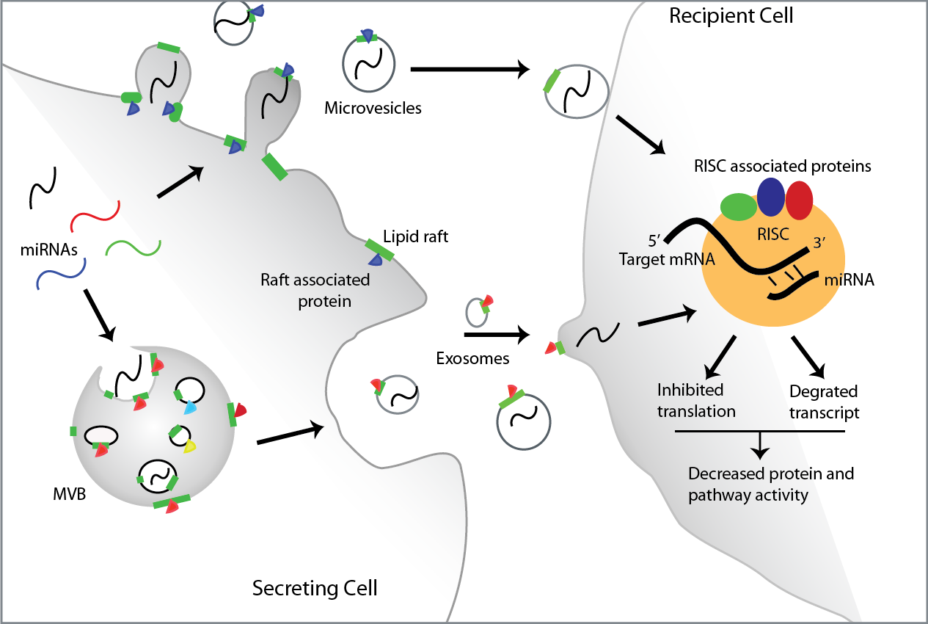

**Figure 1: Extracellular vesicles, secreted miRNAs and their function.** EVs are formed in two different ways: from budding of the plasma membrane to form microvesicles and from fusion of the multivesicular bodies (MVBs) with the plasma membrane to release exosomes. This process requires use of cholesterol rich lipid rafts (green) for formation, facilitated by raft associated proteins (purple and red triangles). EV contents includes miRNAs. Uptake of miRNAs to the recipient cell facilitates the recruitment of the RISC and associated proteins once bound to its target mRNA by complementary binding. This enables down regulation of proteins in the recipient cell by inhibition of translation or degradation of transcript. (Illustration completed on Adobe Illustrator CC 2014)

**Caveolin-1: mediating lipid raft composition**

The caveolin protein family are integral membrane proteins that dictate the formation of caveolae, flask-shaped invaginations of the plasma membrane, by facilitating structural change of membrane curvature and lipid raft composition(Ariotti *et al.* 2015). The three isoforms of caveolin, named CAV1-3, are typically expressed in different types of tissues. CAV1 and 2 are widely expressed, whereas CAV3 is predominately expressed in muscle cells(Engelman *et al.* 1998). Caveolins are cholesterol transporters required in the delivery of cholesterol on the plasma membrane (Smart *et al.* 1996). Membrane bound caveolin are also known to promote a variety of signalling activities, including the mediation of growth, secretion and adhesion(Bosch *et al.* 2011; Guo *et al.* 2011). Lack of CAV1 and 3, through genetic ablation, yields a loss of caveolae formation(Drab *et al.* 2001; Galbiati *et al.* 2001; Razani *et al.* 2001). Furthermore, *de novo* caveolae formation in lymphocytes occur following ectopic expression of CAV1(Fra *et al.* 1995). Hence, CAV1 appears to be essential for caveolae formation, and potentially regulates raft lipid and protein composition. However, recent studies reveal that caveolin alone is not sufficient for stable caveolae production and requires coat proteins of the cavin family (Hill *et al.* 2008).

**Cavins: modifying lipid raft composition.**

The cavin family consists of 4 cavins, named Polymerase I and Transcript Release Factor (PTRF or cavin-1), Serum Deprivation Response (SDPR or cavin-2), Sdr-Related gene product that Binds to C-kinase (SRBC or cavin-3) and Muscle Related Coiled-Coil protein (MURC or cavin-4). These proteins are co-expressed and co-distributed with caveolin and interact with each other as oligomeric cavin complexes in healthy cells in a tissue-specific manner (Nabi 2009).

Cavin-1 plays a major role in modifying caveolin associated lipid rafts and caveolae. Expression of cavin-1 in cells with functional caveolin dramatically increases the caveolae density(Hill et al. 2008). In contrast, cavin-1 knockdown in zebrafish yielded a significant decrease in caveolae formation(Hill et al. 2008). Earlier work from our lab compared GFP transformed PC3 cells to GFP-cavin-1 PC3 cells which revealed a decrease in cholesterol found within the lipid raft fraction upon cavin-1 expression(Inder et al. 2012). Furthermore, cavin-1 led to cholesterol re-distribution, presumably by acting on CAV1 to modify associated lipid raft composition. Neither cavin-2 nor cavin-3 can form caveolae through interaction with CAV1 on their own. Co-immunoprecipitation studies with the cavin members reveal that cavins form distinct complexes which require the presence of cavin-1 with either cavin-2 or cavin-3 (Bastiani *et al.* 2009). Overexpressing cavin-2 in HeLa cell lines, which expresses natural caveolin, was found to increase membrane tubule formation from the caveolae(Hansen *et al.* 2009). Cavin-3 has been associated with internalisation and trafficking by further knockdown and ectopic expression studies(McMahon *et al.* 2009). As cavin-2 and cavin-3 exert a different activity to cavin-1, they are likely to recruit additional proteins to fulfil these functions. Yet, as these other cavins don’t bind to CAV1, it is unlikely cavin-2 and 3 are having an effect on cholesterol in lipid raft composition and therefore cargo export. Cavin-4 is only present in cardiac and skeletal muscle and will associate with Caveolin-3, where its specific action in this system had not been as extensively studied(Bastiani et al. 2009). Manipulating the relationship between CAV1 and cavin-1 provides as a useful tool to assess cholesterol, lipid raft and lipid raft dependant processes.

**Caveolin-1 and cavin-1: association with cargo export.**

Without cavin-1, CAV1 does not form caveolae, but remains in non-caveolar lipid rafts(Moon et al. 2014). Introduction of cavin-1 to this protein-lipid raft modifies the composition by cholesterol re-distribution, as discussed, which had been linked to a number of functional changes. This change in lipid raft composition had been found to alter lipid raft proteome, including changes in cytoskeletal proteins to modify adhesion and cytoskeletal remodelling(Inder et al. 2012). Ectopic cavin-1 expression also induced differential recruitment of 123 proteins to EVs (Inder et al. 2012). In a later study, the microRNA, miR-148a, was found to be strongly underrepresented the EVs upon expression of cavin-1, yet no significant decrease in the cell(Inder et al. 2014). Additionally, while cavin-1 is mediating this change, it is not present within the EVs, indicating an indirect mechanism through lipid raft changes. This suggests that cargo sequestered into the EVs is completed in a selective manner for miRNAs alike protein, which correlates to a change in lipid raft composition from this system.

**Hypothesis:**

This project will assess the hypothesis that miRNAs are selectively exported via extracellular vesicles mediated by lipid raft proteins, using a PC3 model. As cavin-1 cannot directly mediate the export of miRNAs, it is hypothesised that cavin-1 indirectly modulates miRNA escort proteins to lipid rafts, thereby mediating selective miRNA export (Figure 2).

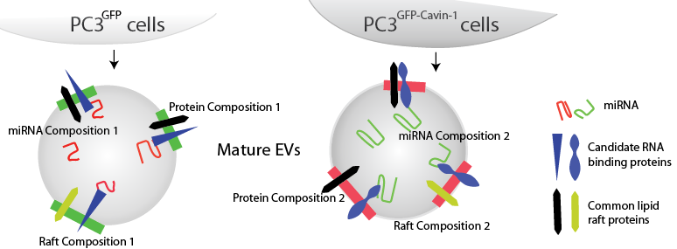

**Figure 2: Diagrammatic representation of the hypothesis.** It is hypothesised that EVs released from PC3 cell lines expressing GFP or GFP-Cavin-1 will contain a different miRNA, lipid raft and protein composition compared to the cavin-1 transfected PC3 cell line. While RNA-binding proteins are expected to be specific to the cell line, several common proteins may be shared between the conditions. (Illustration completed using Adobe Illustrator CC 2014)

# **Aims:**

1. Establish the full repertoire of miRNAs that are selectively exported by EVs in response to cavin-1 expression.
2. Identify potential miRNA escort proteins involved with miRNA sorting.
3. Verify the functionality of candidate miRNA escort proteins by assessing binding ability and co-localisation with miRNAs and EVs.

**Methods**:

Figure 3 shows the workflow for the project.

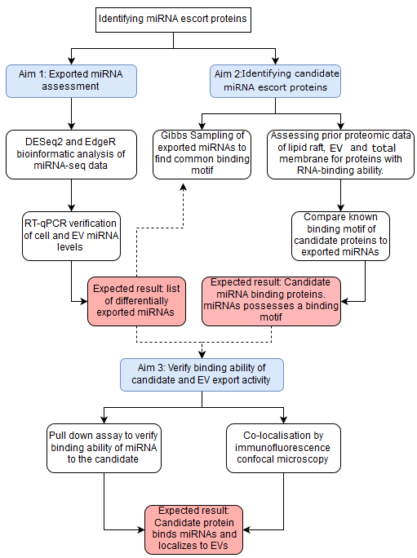

**Figure 3: Workflow diagram** detailing the methods to be used for each aim (blue) and expected results (pink). Dotted lines detail how the results are integrated between methods.

## **Advanced Prostate Cancer cell line: PC3**

PC3 cell line is a model cell line for advanced prostate cancer, which exhibits CAV1 expression without cavins. PC3 expressing GFP and GFP-tagged cavin proteins had previously been generated and characterised (Bastiani 2009), and will be used throughout this project. GFP expressing PC3 cells will be used as a CAV1+/Cavin-1- control.

## **Aim 1: Assessment of exported miRNAs**

A miRNA-seq experiment was performed in the lab to profile the miRNA content in PC3 cells and their EVs. Three replicates of total RNA was extracted from EVs or cell pellets of PC3 cells expressing GFP only or cavin-1::GFP. Small RNA was prepared for sequencing, and the results aligned to the human genome. I have received the raw counts of miRNA species and will perform bioinformatics to analyse the miRNA-seq data and verify candidate miRNAs by RT-qPCR.

Comparing the GFP expressive to the cavin-1 expressive PC3 cell lines should reveal miRNAs that are differentially exported in PC3 model system upon change of lipid raft composition. Further comparing this fold change (FC) in the EVs to the cell change in miRNAs will reveal whether the change in the EVs are selective, and not a product of total cell expression.

### Bioinformatics analysis:

The computational analyses will be completed through R, a commonly used programming language used for statistical analyses and graphing of data. DESeq2 and edgeR packages are two of the more commonly used RNA-seq analysing packages that integrate quality control assessment of data and assess differential expression for bulk samples(Robinson *et al.* 2009; Love *et al.* 2014). Differentially exported miRNAs for further analysis will be considered based on statistical significance, with a p value correction, and magnitude of FC.

### RT-qPCR:

An experimental confirmation of the miRNA level change will be required to verify the computational results. A similar preparation process to the miRNA-seq experiment will be completed to ensure consistent results. This includes EV extraction from healthy PC3 cells, total RNA extraction from EVs and cell pellet using miRvana extraction kit, DNAse treatment to avoid contamination and RT-qPCR. As miRNAs are too small to encompass non-overlapping PCR primers, a poly-A tail will need to be added. This allows for the use of a universal forward primer, as all miRNAs will then contain a poly-A region, with a miRNA specific reverse primer. All samples will be part of a biological triplet, at minimum. Ct values (cycle threshold), which correspond to the miRNA amount in the sample, will be averaged and compared to verify FC between cavin-1 and control PC3 samples and between EV and cell.

### Expectations for Aim 1:

As previous studies had begun to assess this system which revealed differential export of specific miRNAs, including miR-148a, it is expected that upon a more comprehensive assessment that more miRNAs will be found to exert this activity given the change in lipid raft composition by cavin-1 and CAV1 manipulation. Additionally, there is likely to be some miRNAs that change in response to cavin-1, but are a product of non-selective export seen by a proportional increase/decrease to the cell levels, such as the miR-125a found in previous studies(Inder, 2014). These miRNAs may be used as a control as these will should not bind to the miRNA escort protein.

## **Aim 2: Identifying candidate miRNA escort proteins**.

Analysing the differentially exported miRNAs, from aim 1, based on common binding partners can reveal the escort proteins that are mediating export. This section will identify proteins that are present in the lipid raft fraction and EVs that possess RNA-binding abilities. This aim will be realised by bioinformatics analysis of a published proteomic dataset with RNA-binding motif assessment.

### Identify correlated proteins with RNA-binding ability:

Subcellular fractions were analysed by liquid chromatography tandem mass spectrometry to identify proteins as published(Inder et al. 2012). This method was completed on PC3 GFP and PC3 cavin-1 cell lines and compared to assess FC of proteins between these conditions, complete with statistical analyses. A non-ionic detergent, Triton-X100, was used to segregate the detergent-resistant lipid raft from the remaining lipid membrane. Additionally, the EVs were collected from conditioned media. Total membrane fraction was prepared by ultracentrifugation of a cellular homogenate which had the nuclei removed by low-speed centrifugation.

As escort proteins should bind to the miRNA and sequester them into the forming EVs, it would be expected to be more abundant in the EV fraction when the miRNAs are present. Proteins that are enriched in the EV, based on FC, corresponding to a higher miRNA abundance will be assessed for RNA-binding ability. Performing a gene ontology assessment for molecular function, using GeneGo, will reveal the molecular properties relating to these proteins, such as RNA-binding ability. Furthermore, enquiring into their enrichment within the lipid rafts, compared to total membrane, confirms the importance of the lipid raft composition in this process. Hereby, proteins that correlate to miRNA abundance, possess RNA-binding abilities and associate with the lipid rafts will be chosen as candidates for miRNA escort proteins (Figure 4).

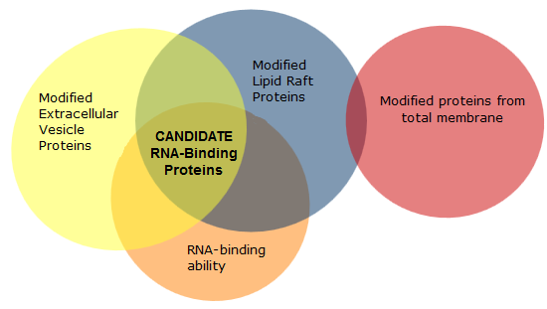

**Figure 4: Comparisons between proteome data required for candidate RNA-binding proteins.** Proteins significantly (P<0.05) modified upon introduction of cavin-1 within the EV and lipid raft data sets that possess RNA-binding ability will be considered the candidate escort proteins. The lipid raft comparison must not contain proteins that were also differentially affected in the total membrane dataset.

### Motif discovery of selectively exported miRNAs:

For the miRNAs to be able to be exported selectively, there would be a shared binding motif to allow for specificity. This motif will be assessed in two ways: Gibbs sampling of the miRNA population to determine the shared motif and by utilising any information regarding the RNA-binding ability of the candidate proteins. Many proteins have an identified binding motif, expressed as a Position Weight Matrix, which can be compared against the exported miRNAs to assess the likelihood of binding. A score is established for each window in each miRNA to find the target motif and how probable that this protein binds(Sinha 2006). Additionally, Gibbs sampling motif discovery method will be used on the exported subset of miRNAs. This algorithm uses probability to converge on a window within the miRNA sequence that is the most probable shared window, and thus binding motif(Stormo 2010).

### Expectations for Aim 2:

This analysis is expected to reveal several proteins that correlate to miRNA export, where some will possess RNA binding abilities. As proteins contain a defined RNA-binding motif, this expected to be shared within each of the selectively exported miRNA sequences. However, it is possible that multiple RNA-binding proteins can be involved in this process, where there would then be different binding motifs for different subsets miRNAs.

## **Aim 3: Validating the candidate miRNA escort protein.**

To confirm the activity of the candidates as miRNA binding proteins with correct miRNA binding, a pull down assay will be performed. This will be followed by attempts to co-localise the miRNA and candidate escort protein by immunofluorescence confocal microscopy in PC3 cells.

### Confirmation of binding ability through pulldown assay:

Biotinylated miRNAs including miR-148a (Inder 2014) will be transfected into PC3 cells, and secretion via EV confirmed by PCR of the pulled down biotinylated miRNA from the EV fraction using streptavidin beads. Streptavidin beads will be used to pull down biotinylated miRNAs and their binding proteins, from whole cell lysate, similar to a previous study(Villarroya-Beltri et al. 2013). Non-selectively exported miRNAs (alike miR-125a found by Inder, 2014) will be used as a negative control in the pull down. Pulled down proteins will be detected using western blot with specific antibodies to candidate miRNA escort proteins. The antibodies will be purchased commercially and first tested on PC3 cell lysates to confirm their performance on western blot.

### Co-localisation by immunofluorescence confocal microscopy:

Biotinylated miRNAs (selectively and non-selectively exported) will be visualised using green fluorescently-tagged streptavidin. Co-localization will be effected by antibody-labelling of the candidate miRNA escort proteins using a red fluorescently tagged secondary antibody. Individual labelling and localisation will be optimised prior to co-localization. Visualising the localisation of the miRNAs and the miRNA escort protein will be completed through confocal microscopy, where co-localisation will be determined based on a change in colour; co-localised tags will be observed as yellow due to the overlap of GFP and red antibody tag. This will be completed for PC3, without ectopic GFP, and PC3-cavin-1 cell lines. Significant co-localisation will be assessed by Pearson correlation.

### Expectations for Aim 3:

It is expected that the candidate miRNA binding protein will be pulled down from the EV fraction correlating to an increase in selective miRNA export. Additionally, the non-selectively exported miRNA should not pull down this candidate. Co-localisation is expected between the miRNA escort protein and the target miRNA, but not the non-selective control miRNA. Ultimately, this will verify the miRNA escort proteins ability to selectively export specific miRNA species upon lipid raft modification by manipulation of CAV1 and cavin-1.

## **Timeline**

|  |  |  |  |  |  |  |  |  |  |
| --- | --- | --- | --- | --- | --- | --- | --- | --- | --- |
| **Honours Timeline** | **Mar** | **Apr** | **May** | | **Jun** | **Jul** | **Aug** | **Sep** | **Oct** |
| **Aim 1** | | | | | | | | | |
| miRNA-seq Analysis |  |  |  |  | |  |  |  |  |
| RT-qPCR |  |  |  |  | |  |  |  |  |
| **Aim 2** | | | | | | | | | |
| Partner Prediction |  |  |  |  | |  |  |  |  |
| Motif Assessment |  |  |  |  | |  |  |  |  |
| **Aim 3** | | | | | | | | | |
| Pull down Assay |  |  |  |  | |  |  |  |  |
| Co-localisation microscopy |  |  |  |  | |  |  |  |  |
| **Thesis Writing** |  |  |  |  | |  |  |  |  |

**Table 1: Honours timeline detailing the estimated time for the completion for each aim.** As aim 3 is entirely laboratory based, and requires development of novel methods, ample time had been allocated for its optimisation and completion. While ample time has been allocated for specifically for thesis writing, it will be an ongoing task throughout the year.

**Significance:**

Completion of this project will reveal a novel aspect of lipid rafts in cellular biology: EV microRNA cargo sorting. As lipid rafts are heavily implicated in the formation of extracellular vesicles, dysfunction can lead to disruption in EV dependent processes such as intracellular communication, immunological response, and neuronal function(Rajendran *et al.* 2014; Robbins and Morelli 2014; Yoon *et al.* 2014). In particular, miRNA release via EVs have been found to play a strong regulatory role in cancers by facilitating tumour growth and angiogenesis in recipient cells, which mediates the basis for metastasis(Skog *et al.* 2008; Zhou *et al.* 2014). Individually, miRNAs, lipid rafts and EVs have been linked to multiple diseases, including hypertension, Diabetes, and Alzheimer’s disease(Simons and Simons 2002; Cohen *et al.* 2003). Hereby, elucidating the molecular mechanisms that link their function and dysfunction to disease could lead to enhanced therapeutics for these potentially life threatening diseases.

# References:

Ariotti, N., J. Rae, N. Leneva, C. Ferguson, D. Loo, S. Okano, M. M. Hill, P. Walser, B. M. Collins and R. G. Parton (2015). "Molecular Characterization of Caveolin-induced Membrane Curvature." Journal of Biological Chemistry **290**(41): 24875-24890.

Bastiani, M., L. Liu, M. M. Hill, M. P. Jedrychowski, S. J. Nixon, H. P. Lo, D. Abankwa, R. Luetterforst, M. Fernandez-Rojo, M. R. Breen, S. P. Gygi, J. Vinten, P. J. Walser, K. N. North, J. F. Hancock, P. F. Pilch and R. G. Parton (2009). "MURC/Cavin-4 and cavin family members form tissue-specific caveolar complexes." The Journal of Cell Biology **185**(7): 1259-1273.

Bennett, N. C., J. D. Hooper, D. W. Johnson and G. C. Gobe (2014). "Expression profiles and functional associations of endogenous androgen receptor and caveolin-1 in prostate cancer cell lines." Prostate **74**(5): 478-487.

Bosch, M., M. Marí, S. P. Gross, J. C. Fernández-Checa and A. Pol (2011). "Mitochondrial Cholesterol: A Connection Between Caveolin, Metabolism, and Disease." Traffic **12**(11): 1483-1489.

Campos, J., #xe3, o. Henrique, R. P. Soares, K. Ribeiro, A. Cronemberger Andrade, #xe9, W. L. Batista and A. C. Torrecilhas (2015). "Extracellular Vesicles: Role in Inflammatory Responses and Potential Uses in Vaccination in Cancer and Infectious Diseases." Journal of Immunology Research **2015**: 14.

Chamberlain, L. H., R. D. Burgoyne and G. W. Gould (2001). "SNARE proteins are highly enriched in lipid rafts in PC12 cells: Implications for the spatial control of exocytosis." Proceedings of the National Academy of Sciences of the United States of America **98**(10): 5619-5624.

Cocucci, E. and J. Meldolesi (2015). "Ectosomes and exosomes: shedding the confusion between extracellular vesicles." Trends in Cell Biology **25**(6): 364-372.

Cohen, A. W., T. P. Combs, P. E. Scherer and M. P. Lisanti (2003). "Role of caveolin and caveolae in insulin signaling and diabetes." The American journal of physiology **285**(6): E1151.

Collino, F., M. C. Deregibus, S. Bruno, L. Sterpone, G. Aghemo, L. Viltono, C. Tetta and G. Camussi (2010). "Microvesicles derived from adult human bone marrow and tissue specific mesenchymal stem cells shuttle selected pattern of miRNAs." PLoS ONE **5**(7): e11803.

De Toro, J., L. Herschlik, C. Waldner and C. Mongini (2015). "Emerging roles of exosomes in normal and pathological conditions: new insights for diagnosis and therapeutic applications." Front Immunol **6**: 203.

Drab, M., P. Verkade, M. Elger, M. Kasper, M. Lohn, B. Lauterbach, J. Menne, C. Lindschau, F. Mende, F. C. Luft, A. Schedl, H. Haller and T. V. Kurzchalia (2001). "Loss of Caveolae, Vascular Dysfunction, and Pulmonary Defects in Caveolin-1 Gene-Disrupted Mice." Science **293**(5539): 2449-2452.

Engelman, J. A., X. Zhang, F. Galbiati, D. Volonté, F. Sotgia, R. G. Pestell, C. Minetti, P. E. Scherer, T. Okamoto and M. P. Lisanti (1998). "Molecular Genetics of the Caveolin Gene Family: Implications for Human Cancers, Diabetes, Alzheimer Disease, and Muscular Dystrophy." The American Journal of Human Genetics **63**(6): 1578-1587.

Falcone, G., A. Felsani and I. D’Agnano (2015). "Signaling by exosomal microRNAs in cancer." Journal of Experimental & Clinical Cancer Research : CR **34**(1): 32.

Fra, A. M., E. Williamson, K. Simons and R. G. Parton (1995). "De novo formation of caveolae in lymphocytes by expression of VIP21-caveolin." Proceedings of the National Academy of Sciences of the United States of America **92**(19): 8655-8659.

Galbiati, F., J. A. Engelman, D. Volonte, X. L. Zhang, C. Minetti, M. Li, H. Harry, Jr., B. Kneitz, W. Edelmann and M. P. Lisanti (2001). "Caveolin-3 Null Mice Show a Loss of Caveolae, Changes in the Microdomain Distribution of the Dystrophin-Glycoprotein Complex, and T-tubule Abnormalities." Journal of Biological Chemistry **276**(24): 21425-21433.

Gregory, R. I., T. P. Chendrimada, N. Cooch and R. Shiekhattar (2005). "Human RISC couples microRNA biogenesis and posttranscriptional gene silencing." Cell **123**(4): 631-640.

Gu, H., A.-M. C. Overstreet and Y. Yang (2014). "Exosomes Biogenesis and Potentials in Disease Diagnosis and Drug Delivery." Nano LIFE **04**(04): 1441017.

Guo, C. J., X. B. Yang, Y. Y. Wu, L. S. Yang, S. Mi, Z. Y. Liu, K. T. Jia, Y. X. Huang, S. P. Weng, X. Q. Yu and J. G. He (2011). "Involvement of caveolin-1 in the Jak-Stat signaling pathway and infectious spleen and kidney necrosis virus infection in mandarin fish (Siniperca chuatsi)." Mol Immunol **48**(8): 992-1000.

Hannafon, B. N. and W.-Q. Ding (2013). "Intercellular Communication by Exosome-Derived microRNAs in Cancer." International Journal of Molecular Sciences **14**(7): 14240-14269.

Hansen, C. G., N. A. Bright, G. Howard and B. J. Nichols (2009). "SDPR induces membrane curvature and functions in the formation of caveolae." Nature Cell Biology **11**(7): 807-814.

Hashimoto, Y., Y. Akiyama and Y. Yuasa (2013). "Multiple-to-multiple relationships between microRNAs and target genes in gastric cancer." PLoS ONE **8**(5): e62589.

Hill, M. M., M. Bastiani, R. Luetterforst, M. Kirkham, A. Kirkham, S. J. Nixon, P. Walser, D. Abankwa, V. M. J. Oorschot, S. Martin, J. F. Hancock and R. G. Parton (2008). "PTRF-Cavin, a Conserved Cytoplasmic Protein Required for Caveola Formation and Function." Cell **132**(1): 113-124.

Inder, K. L., J. E. Ruelcke, L. Petelin, H. Moon, E. Choi, J. Rae, A. Blumenthal, D. Hutmacher, N. A. Saunders, J. L. Stow, R. G. Parton and M. M. Hill (2014). "Cavin-1/PTRF alters prostate cancer cell-derived extracellular vesicle content and internalization to attenuate extracellular vesicle-mediated osteoclastogenesis and osteoblast proliferation." J Extracell Vesicles **3**.

Inder, K. L., Y. Z. Zheng, M. J. Davis, H. Moon, D. Loo, H. Nguyen, J. A. Clements, R. G. Parton, L. J. Foster and M. M. Hill (2012). "Expression of PTRF in PC-3 Cells modulates cholesterol dynamics and the actin cytoskeleton impacting secretion pathways." Mol Cell Proteomics **11**(2): M111.012245.

Lang, T., D. Bruns, D. Wenzel, D. Riedel, P. Holroyd, C. Thiele and R. Jahn (2001). "SNAREs are concentrated in cholesterol-dependent clusters that define docking and fusion sites for exocytosis." The EMBO Journal **20**(9): 2202-2213.

Leyt, J., N. Melamed-Book, J. P. Vaerman, S. Cohen, A. M. Weiss and B. Aroeti (2007). "Cholesterol-sensitive modulation of transcytosis." Mol Biol Cell **18**(6): 2057-2071.

Love, M. I., W. Huber and S. Anders (2014). "Moderated estimation of fold change and dispersion for RNA-seq data with DESeq2." Genome Biology **15**(12): 1-21.

Low, J.-Y. and H. D. Nicholson (2015). "Epigenetic modifications of caveolae associated proteins in health and disease." BMC Genetics **16**(1): 1-10.

McMahon, K.-A., H. Zajicek, W.-P. Li, M. J. Peyton, J. D. Minna, V. J. Hernandez, K. Luby-Phelps and R. G. W. Anderson (2009). "SRBC/cavin-3 is a caveolin adapter protein that regulates caveolae function." The EMBO Journal **28**(8): 1001-1015.

Minciacchi, V. R., M. R. Freeman and D. Di Vizio (2015). "Extracellular Vesicles in Cancer: Exosomes, Microvesicles and the Emerging Role of Large Oncosomes." Seminars in cell & developmental biology **40**: 41-51.

Moon, H., C. S. Lee, K. L. Inder, S. Sharma, E. Choi, D. M. Black, K. A. Le Cao, C. Winterford, J. I. Coward, M. T. Ling, D. J. Craik, R. G. Parton, P. J. Russell and M. M. Hill (2014). "PTRF/cavin-1 neutralizes non-caveolar caveolin-1 microdomains in prostate cancer." Oncogene **33**(27): 3561-3570.

Mulcahy, L. A., R. C. Pink and D. R. F. Carter (2014). "Routes and mechanisms of extracellular vesicle uptake." 2014.

Nabi, I. R. (2009). "Cavin fever: regulating caveolae." Nature Cell Biology **11**(7): 789-791.

Phuyal, S., N. P. Hessvik, T. Skotland, K. Sandvig and A. Llorente (2014). "Regulation of exosome release by glycosphingolipids and flotillins." FEBS Journal **281**(9): 2214-2227.

Razani, B., J. A. Engelman, X. B. Wang, W. Schubert, X. L. Zhang, C. B. Marks, F. Macaluso, R. G. Russell, M. Li, R. G. Pestell, D. D. Vizio, H. Harry, Jr., B. Kneitz, G. Lagaud, G. J. Christ, W. Edelmann and M. P. Lisanti (2001). "Caveolin-1 Null Mice Are Viable but Show Evidence of Hyperproliferative and Vascular Abnormalities." Journal of Biological Chemistry **276**(41): 38121-38138.

Robinson, M. D., D. J. McCarthy and G. K. Smyth (2009). "edgeR: a Bioconductor package for differential expression analysis of digital gene expression data." Bioinformatics **26**.

Simons, K. and K. Simons (2002). "Cholesterol, lipid rafts, and disease." The Journal of clinical investigation **110**(5): 597-603.

Sinha, S. (2006). "On counting position weight matrix matches in a sequence, with application to discriminative motif finding." Bioinformatics **22**(14): e454-e463.

Smart, E. J., Y.-s. Ying, W. C. Donzell and R. G. W. Anderson (1996). "A Role for Caveolin in Transport of Cholesterol from Endoplasmic Reticulum to Plasma Membrane." Journal of Biological Chemistry **271**(46): 29427-29435.

Stoorvogel, W. (2015). "Resolving sorting mechanisms into exosomes." Cell Res **25**(5): 531-532.

Stormo, G. D. (2010). "Motif discovery using expectation maximization and Gibbs' sampling." Methods in molecular biology (Clifton, N.J.) **674**: 85-95.

Trajkovic, K., C. Hsu, S. Chiantia, L. Rajendran, D. Wenzel, F. Wieland, P. Schwille, Br, xfc, B. gger and M. Simons (2008). "Ceramide Triggers Budding of Exosome Vesicles into Multivesicular Endosomes." Science **319**(5867): 1244-1247.

Valadi, H., K. Ekstrom, A. Bossios, M. Sjostrand, J. J. Lee and J. O. Lotvall (2007). "Exosome-mediated transfer of mRNAs and microRNAs is a novel mechanism of genetic exchange between cells." Nat Cell Biol **9**(6): 654-659.

Villarroya-Beltri, C., C. Gutiérrez-Vázquez, F. Sánchez-Cabo, D. Pérez-Hernández, J. Vázquez, N. Martin-Cofreces, D. J. Martinez-Herrera, A. Pascual-Montano, M. Mittelbrunn and F. Sánchez-Madrid (2013). "Sumoylated hnRNPA2B1 controls the sorting of miRNAs into exosomes through binding to specific motifs." Nat Commun **4**.

Yoon, Y. J., O. Y. Kim and Y. S. Gho (2014). "Extracellular vesicles as emerging intercellular communicasomes." BMB Reports **47**(10): 531-539.